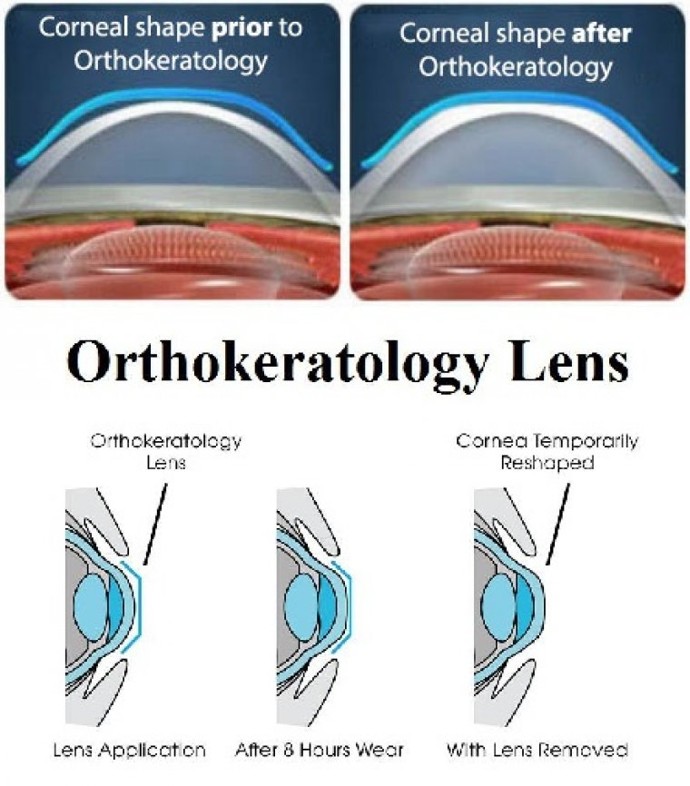

Myopia Progression & Multifocal – Orthokeratology Lenses
July 11, 2021
The prevalence of myopia is increasing worldwide and has reached epidemic levels in parts of Asia. The abnormal enlargement of the eye, which is the structural basis of the myopic refractive error, typically begins in childhood and progresses until early adulthood.
The progressive eye enlargement also causes the tissues of the eye to become stretched and damaged, making myopia a significant risk factor for sightthreatening conditions such as glaucoma, retinal detachment, and myopic maculopathy later in life.
Since the relative risk of developing these conditions increases sharply as myopia progresses to higher degrees, there is significant interest in controlling myopia progression during childhood, when the rate of eye enlargement is typically highest.
A variety of methods for controlling myopia progression is available, including nightly instillation of atropine eye drops, multifocal contact lenses, defocus incorporated (DIMS) spectacles, and orthokeratology.
The relative efficacy of these methods in slowing eye enlargement in the longer term is controversial and difficult to assess.
However, none of these methods come close to totally eliminating myopia progression in the longer term, and so there is significant room for improving efficacy of these methods.
Orthokeratology and multifocal contact lenses provide clinically meaningful reductions in progression of myopia, research shows, but some questions, such as the ideal treatment duration, remain unanswered.
As myopia rates continue to soar to epidemic levels worldwide, research has found that the use of orthokeratology and multifocal contact lenses provide clinically meaningful reductions in progression of the refractive error.
Ophthalmologist Dr. Amy K. Hutchinson recently commented on this. “Both lens types are thought to have a similar mechanism of action to slow myopic progression, and that mechanism is to eliminate peripheral hyperopic defocus and induce peripheral myopic defocus,” she said.

Peripheral hyperopic defocus occurs when myopia is corrected by monovision glasses or contact lenses. The central light rays focus on the fovea and provide a clear image, but peripheral light rays focus behind the plane of the retina, which is thought to play a role in myopia progression, she explained.
According to Dr. Hutchinson, in support of this, clinical observations show a “significant reduction in myopia progression when bifocal glasses, multifocal contact lenses or overnight orthokeratology lenses are used to reduce the peripheral hyperopic defocus”.
When measuring myopia progression, the result is expressed as the percentage of the changes in dioptric progression or axial lengthening between a treatment and control group; a 50% slowing is considered ideal and over 30% acceptable.

Multifocal Contact Lenses
The centre distance design is used most often in multifocal lenses, in which the central area of the lens focuses the image on the fovea.
“The peripheral area has a more positive power resulting from either distinct concentric rings or a gradual progressive increase toward the periphery,” Dr Hutchinson explained.
This design provides the wearer with clear central vision and both eliminates the peripheral hyperopic defocus and introduces peripheral myopic defocus, which decreases the stimulus for myopic progression associated with monovision glasses and contact lenses.
Currently, the MiSight multifocal contact lens by Cooper Vision is the only United States Food and Drug Administration-approved contact lens for myopia control. It has concentric peripheral rings that include a +2.00 D add.
In a 3-year study, the lens slowed myopia progression in children (aged 8-12 years; refractive errors up to -4.0 D) by 59% and axial elongation by 52% compared with age-matched control children.
Other spherical and toric multifocal lenses are available for off-label use. Dr Hutchinson noted that evidence has suggested that higher add powers may result in better control of myopia progression.
These lenses have been shown to slow myopia progression by -9.7–70% and slow axial elongation by 0–79%.

Orthokeratology
Orthokeratology lenses are worn overnight and temporarily reshape the cornea. “This technology uses a reverse-geometry rigid gas-permeable contact lens in which the base curve radius is flatter than the central corneal curvature, and the secondary curve is steeper than the base curve radius,” said Dr Hutchinson.
The central corneal flattening focuses the image on the fovea and eliminates the need for the patient to wear correction during the day. The lens steepens the mid-peripheral cornea and induces myopic defocus on the peripheral retina, thus controlling the myopia.
The lenses, which are most useful for patients with low to moderate myopia, have demonstrated a 30–80% slowing of axial elongation.
Slowing of the dioptric progression is not usually reported because the lenses cause a temporary shift in the refractive shift. There is some evidence that these lenses might be useful to treat anisometropia as well.
In the US, orthokeratology lenses are approved for wear overnight but not for myopia control, whilst in Europe, the Menicon Bloom lens (Menicon) is CE-marked for the control of myopia progression, one version being for nightly use and a second type designed for daily use.
However, safety with overnight contact lens wear has been a pervasive concern. There has only been one large retrospective study to estimate the incidence of microbial keratitis associated with overnight orthokeratology lens wear.
Based on the upper confidence interval of this study, the expected incidence of microbial keratitis is no more than 50 per 10,000 patient years, or 1 in 200 years of wear. However, avoiding the use of tap water is recommended.
Overall, despite the reported success with contact lens wear to slow myopia progression, questions remain unanswered, including the ideal time to begin treatment, recommended treatment duration and what the rate of rebound myopia is with discontinuation of contact lens wear.

