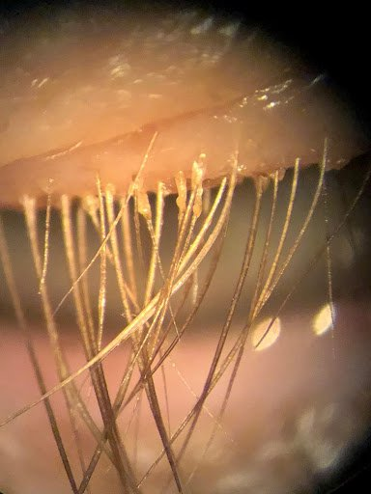
“Demodex are small mites that live on our skin, specifically in our hair follicles and oil glands. It is completely normal for these mites to be there, as we will all have them at some point in our lives, and, normally, they do not cause any issues. However, in some cases, the number of mites present gets too high, which leads to a buildup of their waste on our eyelids and eyelashes which causes irritation and redness. They can also clog up our oil glands which can cause styes to form.
Because these mites are not a bacterium or virus they cannot be treated with antibiotic or antiviral medication, so this makes them a little more difficult to treat.
The treatment that does work on the mites is tea tree oil which comes from the tea tree plant. This oil is very strong so it can be irritating to the eyes when you use it, but a strong treatment is needed because the mites can be very difficult to get rid of. When you apply the oil make sure to get it on the lids and lashes, especially near the margin of your lids because that is where the mites live. Try to avoid getting any of the oil in the eye itself because you will feel a stinging sensation if you do, this will not damage your eye, but it will be uncomfortable for a little while.
Also make sure to use the oil on your cheeks, nose, forehead, and eyebrows because the mites can live in these areas as well. We cannot get rid of all the mites even with tea tree oil treatment, so our goal is to bring down the number of mites to the point where they no longer cause any issues. The mites do come back in some cases, so you may have to use the tea tree oil long-term if needed, but you may not have to use it as often.”

